Welcome to English II!
  Ms. Sharpe  Room #: T4  Phone: 281-329-0408  Email: courtney.sharpe@fortbendisd.gov |  |  | 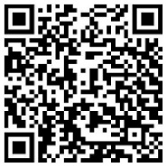
  Class Information  - Upcoming assignments and the class calendar will be posted to Schoology.  - You are responsible for checking Schoology regularly.  - You may message me from Schoology with questions about this course.  - If you submit a Schoology assignment late, it is your responsibility to email me; otherwise, I may not see it.  - If you are absent on a due date, it is YOUR responsibility to reach out to me as soon as possible to discuss. | 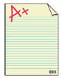  Grades & Academic Integrity  Grades follow FBISD guidelines:  - 50% - Major grades (projects, tests, essays)  - 50% - Daily grades (classwork, homework, quizzes)  To monitor your grades, please see Skyward.  =>If you have questions about a grade, do not wait until the end of the term to ask.  **Plagiarism and Academic Dishonesty will not be tolerated. Any assignment completed dishonestly will earn a zero. See the Late Work and Cheating Policy at the end of this syllabus for specific details.**
Supplies  - Spiral Notebook  - Pens & Pencils    - Highlighters  Class Donations  - 1st: Hand sanitizer  - 2nd: Tape  - 4th: Tape  - 5th: Pack of glue sticks  - 6th: Pack of 2” Post-It Notes  - 7th: Pack of 2” Post-It Notes | Tutorials    Mornings:  - 7:00 -7:20 by appt. only  - Tutoring pass is in Schoology.  Afternoons:  - Monday and Thursday 2:50 – 3:30 P.M.  (Subject to change as needed.)
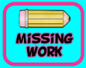  Makeup Work  - 1 day/each day absent.  - Students are responsible for checking the Absent Folder & completing missing work (including class notes).  - If nothing is in the Absent Folder, ASK!  - Late work is -10/day up to 5 days.  - After 5 days, it is your responsibility to have a conversation with me to discuss, at teacher’s discretion, how to proceed to potentially complete the assignment for up to a 50. | This Year’s Readings    Below is a list of books and plays we may read this year. It is your responsibility to do your research and share concerns with me in advance.  - Twelve Angry Men by Reginald Rose  - In Cold Blood by Truman Capote  - Fahrenheit 451 by Ray Bradbury  - Book Club texts  - A letter will be sent if additional texts are selected by the English II team.
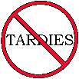  Tardies  - If you are tardy to class, you must bring a tardy pass.  - Without a pass, you will be counted TARDY. No exceptions. Be on time! | 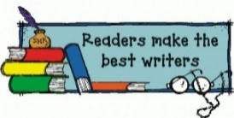  Readers Write & Writers Read  In this class we will read a lot,  and we will write a lot. Enjoy it!
  Technology in the Classroom  - Now that we are a one-to-one campus, you are responsible to charge your laptop at home each night.  - Bring your CHARGED laptop to school each day.  - Again, students are required to use the district issued laptop for all school work.  - Electronics should be in your backpack at all times unless otherwise instructed.  - Electronic devices include cell phones, ear buds, headphones, laptops, tablets, *smart watches, and any new invention not already mentioned.  - *Smart watches will be removed during all assessments.  - I will treat you like an adult until you stop acting like one.  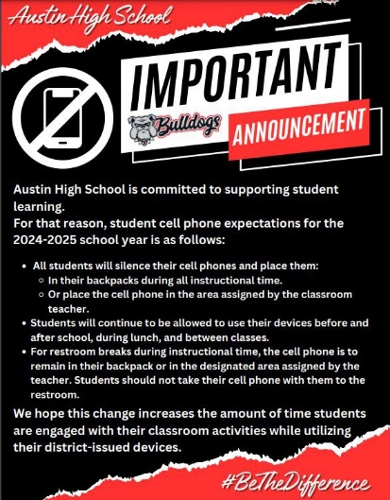 |  | Class Expectations  - Make the right choices.  - Do your personal best.  - Respect yourself, each other, and the classroom.  - Recycle paper & throw away trash.  - Have a book in your hand every day.  - Follow all school & district policies.  Class Consequences    - Verbal warning  - Seat change and/or parent phone call  - Office referral  Reassessment  - Any major grade that earns a original score of a 74 or below can be reassessed for up to a 75. Your teacher will discuss your options with you.  - If you are struggling on daily grades, please see your teacher for reteaching opportunities during tutorials.
Important Things to Remember:  - Open your mind to others’ ideas even if they differ from your own.  - If you do not agree with others’ thinking, then your job is to listen to their argument and try to understand why they feel the way they do.  - Look for faults in how arguments are constructed, but you may not insult another’s opinion.  - Listen twice as much as you speak. We have two ears and one mouth for a reason.  - If you feel strongly about not participating in an activity with the topic we are addressing, have a conversation with me. That’s part of developing mature communication skills.  - Prepare to push yourself harder than you have ever pushed yourself. This class is challenging, but it is rewarding.  - Have a book in your hand every day. If you need help selecting a book, let me help you. I LOVE to help find the right books for you!  - Last but not least, I love my job, my classroom, and my students! I hope you love it here, too.  **It is your job to inform me as your teacher of any issues, ideas, or language that make you uncomfortable to help me create a safe and trusting classroom environment.** |  | Sharpe’s English II  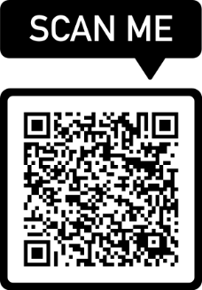  Syllabus & Class Contract 2024 – 2025  Scan the QR code above to sign that you have read and understand the expectations of this class.  If there is anything that I need to be aware of, please let me know on the last question when you complete the form, so I can make the appropriate accommodations as needed. I look forward to the fantastic year ahead!
Austin High School English Late Work & Cheating Policy

English 1 & 2: Students will receive 10 points off the first day, and ten points off days 2-5. After day 5, it is up to a teacher’s discretion how to proceed to work with the student to complete their assignment for up to a 50.

- Extenuating Circumstances: It is the responsibility of the student to communicate any extenuating circumstances that will impact the completion of their work or their ability to turn it in on time. This includes any absences, illnesses, activities, or technological difficulties that can interfere with completing or submitting assignments on time. As a part of the FBISD Profile of a Graduate, it is the student’s responsibility to advocate for themselves and communicate effectively with their teacher or any collaborative peers, so we can all best accommodate students to be successful. This could include assigning an individual assignment if a student is unable to effectively work with others.

- Revision assignments: To best provide timely feedback in the classroom and teach the writing process, if a student does not come to class prepared on the days of peer revision and feedback assignments, the student is disrupting the classroom learning. Additionally, a student will not be able to document their work and could encourage the use of AI. The student will lose points on the writing assignment according to the late work policy (up to the teacher’s discretion) and may be required to do an alternative assignment by hand.

- Cheating and AI: The use of AI in our classroom is strictly prohibited unless specifically authorized by the teacher. Teachers will use Turnitin.com and other resources to check for originality of student work. Any assignment with over a 20% similarity score (See Similarity Scores document in Schoology) is considered plagiarism whether it is the inability to write in their own voice and avoid assimilating work they find elsewhere or indicates that AI software was used to write the work. Students will be required to keep all their work in a Shared OneDrive folder with me for this class so that any work that may be considered plagiarized or questionable can be thoroughly investigated to protect you, the student, with date and time stamps of work. Additionally, you will be required to save all work with a proper title so that assignments may be easily located in OneDrive.

- In order to create a healthy classroom environment for both the student and teacher, handwritten first drafts and/or drafts in Eduphoria with a lockdown browser will be used to promote critical thinking skills. Additionally, students will be expected to use MS Word online edition to document and time stamp their work electronically as directed by the teacher. It is expected that all students will create an organized system to save their work and name their electronic files.

- No PDFs will be accepted of work during the writing process.
- A zero will be entered in to Skyward until the work is submitted correctly.

- If the student is suspected of cheating, the student will receive a zero, pending investigation. Colleges have a zero-tolerance cheating policy, and we are trying to prepare them to be successful in high school and beyond. For a first-time offense, the student will need to conference with their teacher, so they can understand what they are doing wrong and how to fix the problem. If the problem persists, disciplinary procedures will take place. Note: All cheating offenses will be reported to all National Honor Societies which can affect your eligibility status.

Standard for Similarity Scores
English II

OVERVIEW
As part of the course, students will submit written assignments through the plagiarism tool and must avoid excessive amount of text evidence and/or blatant cheating. Similarity Scores should always be 20% or below.

PENALTY
If a student’s Similarity Score is above 20%, assignments will be penalized as follows:

Similarity Score | Penalty
21-25% | -5 points
26-30% | -10 points
31-35% | -15 points
36-39% | -25 points
>40% | Assignment receives a 0

Expectations as Part of the FBISD Profile of a Graduate

In order to equip you with skills for life, our goal is to create effective communicators who can adapt their communication style to the audience, who can prioritize the needs of others while accepting responsibility for themselves and become accountable for their own actions.

- We will read, watch, and discuss a variety of topics in our class this year because we are evaluating how people from different cultures, creeds, time-periods, backgrounds, and work-fields evaluate the world around them through their own expressions. These skills are mandatory, assigned by the State of Texas through its Texas Essential Knowledge & Skills (TEKS) that we are required to help high school students learn.

- As a class, we want you to make your own inferences and opinions and share them. We will discuss, read, and write about a variety of topics that may be controversial to you. In some cases, you may be exposed to ideas that are contrary to your own beliefs. The goal is to teach you how to communicate in a constructive dialogue using concrete details, various argumentative strategies, and facts, not to change your personal beliefs. In our efforts to help create constructive discourse, we may watch or read a piece of text that could contain potential questionable language, ideas, or material to you. However, we will teach you how to analyze rhetoric and create your own arguments while exposing you to a variety of ideas from different cultures, creeds, backgrounds, and time periods that will help you learn and understand a variety of perspectives. We are teaching rhetoric. There will be more than one side to every issue/argument. You need to understand each side as well as the issue’s historical evolution to be able to evaluate how and why different people think the way they do.

It is your job to inform your teacher of any issues, ideas, or language that make you uncomfortable to help us create a safe and trusting classroom environment. But, remember that:
- You need to be open to other people’s ideas.
- If you do not agree with the ideas, then your job is to listen to the other side’s argument and understand, explain, and argue how they put that argument together.
- You can look for faults in the way arguments are constructed.
- Your job is not to put down the other side. Putting down others repeatedly will result in disciplinary action.
- Your job is to take these new ideas and form your own argument from what you know.
- If you feel strongly about not wanting to participate in an activity with the topic we are addressing, please tell me ahead of time, so we can discuss any concerns. If necessary, we can provide an alternative assignment.

We will provide a list of texts, novels, and media that we will be reading this year. All novels of the FBISD approved book list have been thoroughly vetted. Novels that are selected for Self-Selected Reading (SSR) need to be vetted by the student and parent.

**Please scan the QR code at the end of page 2 of the syllabus to list any concerns on the Microsoft Form. Sign and date that you and your parents understand and agree to the expectations of the class syllabus, the Late Work and Cheating Policy, and the FBISD Profile of a Graduate.

